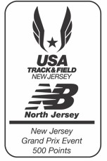Family & Community Services of Somerset County’s
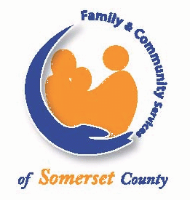“Don’t Fall, Let’s Run!”
5K Run/Walk & Kid Sprint
Saturday, October 24th, 2015
Rain or Shine

9:00 Walkers/Runners & 10:00 Kid Sprint

Somerset County’s Park Commission’s Duke Island Park, Bridgewater, NJ
Paved, wooded trails along the Raritan River

Entry Fee: 5K runners/walkers: $25 & USATF-NJ members $22 by 10/10/15
5 K runners/walkers: $30 & USATF-NJ members $27 after 10/10/15
Kid Sprinters: $10 by 10/10/15 or $15 after 10/10/15

Registration: Mail or Online at www.runsignup.com
Mail form to and make checks payable to:
Family & Community Services of Somerset
Attn: Amy Herrick
339 West Second Street
Bound Brook, NJ 08805

Race Day Registration & Packet Pick Up: Starting at 8:00 am

Awards: Awards Ceremony approx. 10:30 am
Top 3 M/F Overall
Top 3 M/F in Standard Age Groups

Age Groups: 19 & Under, 20 to 29, to 80 & Over in 10 Year Increments

All Proceeds from this race benefits Family & Community Services of Somerset County.
FCS is a nonprofit agency that offers mental health, addictions, and other community based services to all. Please visit our website www.fcssomerset.org.

Please complete all required information.
Name Address

City, State, Zip code

Email Phone#

Emergency Contact Name & Phone#

Waiver: I, intending to be legally bound, hereby for myself, my heirs, executors, and administrators, waiver and release any and all rights and claims I may have against Family and Community Services of Somerset County, the county of Somerset, and all sponsors, and other persons or organizations connected with the above named event,
and their respective agents, employees, officers, volunteers, representatives, successors, and assignees for any and all injuries that may be suffered by me in connection with this event. Further,
I hereby certify that I am physically able to participate in this event and hereby grant the right to publish my name in the news media and use my likeness in any photographic record for the Family and
Community Services of Somerset County “Don’t Fall, Let’s Run” 5K run,
1 Mile walk, and Kids Sprint. Rain or Shine, no refunds.

Sex Date of Birth Age on Race Day

2015 USATF-NJ Membership #
*Complimentary T-shirts to Pre-Registrants
(While Supplies Last)
Choose Size:
S M L XL (please circle one)

Signature of parent or guardian if under 18

Office Use Only
BIB#:

